**Transfer learning and fine-tuning:**

**Transfer learning**

Definition:

Transfer learning is an approach to machine learning where a model trained on one task is used as the starting point for a model on a new task. This is done by transferring the knowledge that the first model has learned about the features of the data to the second model.

In transfer learning, one or more layers from a trained model are used in a new model for a related problem.

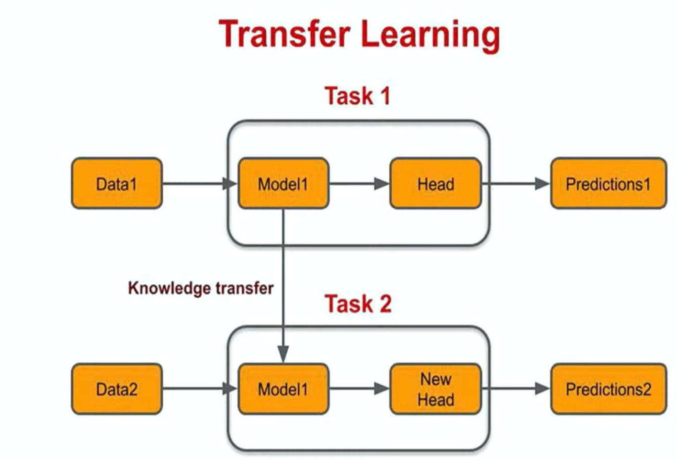

**Definition of Fine-Tuning**

Fine-tuning is the process of taking a pre-trained model and adjusting its weights slightly to make it perform better on a specific task or dataset. This is usually done after the model has already been trained on a large dataset and adapted to a new task using transfer learning.

The first CNN layers are used to extract high level general features. The last couple of layers are used to perform classification (on a specific task).

So we copy the first trained layers (base model) and then we add a new custom layers in the output to perform classification on a specific new task.

**Why Use Transfer Learning?**

* Reduces computational cost and training time.
* Requires less data for training.
* Often achieves better performance for related tasks.

**STEPS**

**1. Pick a Pre-trained Model**

* Choose a model already trained on a large dataset (e.g., ResNet, VGG, BERT).
* Example: Use ResNet (trained on ImageNet) to classify flowers.

**2. Load the Pre-trained Model**

* Load the model into your program.
* Remove the last layer (because it's specific to the old task).

**Example**: "I want ResNet, but without the layer that says 'This is a cat.'"

**3. Freeze the Pre-trained Layers**

* Lock the pre-trained layers so their weights don’t change during training.
* Why? Because these layers already know general features like edges and shapes.

**Example**: "Keep what the model already knows and don’t mess it up."

**4. Add Your Own Layers**

* Add new layers on top of the pre-trained model.
* These new layers will learn to solve your specific task (e.g., classify flowers).

**Example**: "Let’s add a layer that says, 'This is a rose or a sunflower.'"

**5. Train the New Layers**

* Train only the new layers while the rest of the model stays frozen.
* This step is quick because the model already knows the basics.

**Example**: "Teach the model to recognize flowers using what it already knows about shapes and patterns."

**6. Fine-Tune the Model**

* Unlock (unfreeze) some pre-trained layers and retrain them to make the model even better for your task.
* Use a small learning rate to avoid ruining the pre-trained knowledge.

**Example**: "Let’s tweak the details to make it really good at flowers."

**7. Test the Model**

* Check how well the model works on new data.
* Use metrics like accuracy to measure its performance.

**Example**: "Test it on photos of flowers it hasn’t seen before."

**8. Save and Use the Model**

* Save the model so you can use it in real-world applications.
* Example: Build a flower recognition app.

